**Tower Bridge**

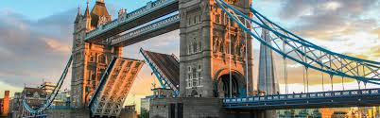Tower Bridge London (English: Tower Bridge) is a construction of a suspension bridge with a lifting bridge (which can open for large boats to pass) across the River Thames in London, the capital of the United Kingdom of Great Britain. The bridge was completed in 1894 and is located on the Tower of London, becoming a famous symbol, associated with the city of London and with England in general. This is also the last bridge down the Thames stream in the city territory. The bridge is often confused with the London Bridge (London Bridge) located not far from it.

**History**

Since the mid-19th century, trade has flourished in East London, leading to the need for a new bridge to support the London Bridge. A fixed bridge in the traditional way of construction would not be appropriate because it would cut the access to the small port of Pool of London, then between London Bridge and Tower of London. A special Research Committee for the Tunnel or Bridge was established in 1876, chaired by Sir AJAltman, to find a solution to the problem of connecting the banks of the River Thames. More than 50 designs were nominated, but it was not until 1884 that the designs of Horace Jones, an architect of the City Council, were approved. Architect John Wolfe Barry develops design ideas. In 1886, the construction began and completed after 8 years with 5 contractors and had to hire 432 construction workers. Two massive foundation foundations with 70,000 tons of concrete were buried in the river bed to support the whole project. More than 11,000 tons of iron and steel were used as frames for the two towers and walkways, then covered with Cornwall granite and Portland rock, both of which protected the steel structure below and gave The bridge is quite beautiful.